Meet the band

**Instruments:** Piano, Tenor Saxophone, Alto Saxophone, Soprano Saxophone, Baritone Saxophone, Clarinet

 Kimberly Altenberg

Alto Saxophone

Joined band - May 2020 - present

Kimberly has a broad music background.  She began playing the piano at age 9 and has been playing ever since.  She studied Piano Performance in college, graduating from Olivet Nazarene University.  Kimberly also played percussion instruments in her grade school band.  She currently plays alto saxophone in the Bayside Baptist Church Orchestra.  She has also enjoyed singing in various choirs throughout her life.  She currently teaches piano, saxophone and voice at Silverdale Baptist Academy.  She began playing the saxophone in 2020.

**Instruments:** Piano, Organ, Percussion, Alto Saxophone

**Instruments:** Tenor Saxophone, Alto Saxophone, Soprano Saxophone, Clarinet

Ain't Just Whistlin' Dixie - Jazz Band   The Happiest Music on Earth!

Jim Altenberg

Soprano & Tenor Saxophone

Clarinet

Joined band - May 2020

Jim began taking saxophone lesson at 9 years of age. He played the Alto saxophone in his grade school band.  Jim currently plays the alto & tenor saxophone in the Bayside Baptist Church Orchestra.  He also began playing the clarinet in January of 2021.

RubyMarie Altenberg

Tenor, Baritone & Soprano Sax

Joined band - May 2020 - present

RubyMarie began studying the Piano at the age of 9 and has been playing and taking lessons ever since.  She sings in the Silverdale Baptist Academy (SBA) Choir, Bayside Baptist Prayz Choir and the SBA Highschool Praise Band.  RubyMarie began playing the saxophone at 11.  She plays the baritone saxophone in the Bayside Baptist Church Orchestra, SBA Highschool, Marching Band, SBA Concert Band and SBA Jazz Band.

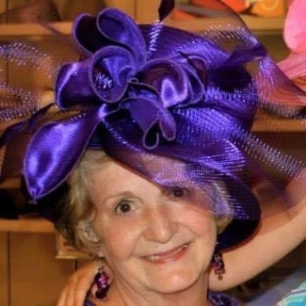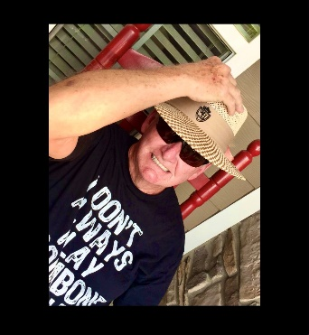 Chris began playing the trumpet at 9.  Starting in grade school he played trumpet every Sunday in church.  Chris played in his high school marching bands in both Ohio and Florida gaining the opportunity to play in regional competitions.  In his senior year Chris won the John Phillip Sousa award honoring him as the top student in his high school band.  He began studying music at Tennessee Temple University where he played in several brass ensembles.  Since graduating he has continued to play in groups that have toured in the U.S., Canada and Europe.  God has blessed him with the opportunity to play his trumpet in more than 30 countries.  Chris has served as the music pastor for Stuart Heights Baptist and Oakwood Baptist 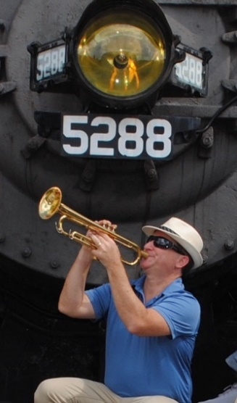Church.  He is currently the orchestra director and student choir director at Bayside Baptist Church.

Meet the band

Seane Crews

Percussion & Wash board

Joined band - September 2021 - present

Seane started playing the guitar at the age of 12.  He has been playing for over 45 years while learning other instruments as well through the years.  Seane also enjoys building and playing cigar box guitars.  He played guitar in a classic rock band - Greystone Drive, and he plays the guitar and the Cajon in the Ooltewah Baptist Church Praise and Worship Band.

**Instruments:** Percussion, Wash board, Guitar, Cajon, Dulcimer, Ukulele, Banjolele

**Instruments:** Piano, Banjolele, Tambourine

Velma Willis

Banjolele & Tambourine

Joined band - June 2020 - present

Velma started piano lessons around the age of 9 and by 13 she was the pianist at her church in Gulfport, MS.  She has been playing the piano ever since.  Velma played piano for her husband's (Gordon) quartet, for various choirs and she played piano and sang with their family ensemble.  She began playing the banjolele in June of 2021.

Gordon Willis

Trombone

Joined band - June 2020 - present

Little Gordon started playing the trombone at the age of 9.  He played trombone in his grade school band and then graduated to his high school marching band.  Gordon spent many years singing in choirs, a gospel quartet and an ensemble with his wife and children.  He also volunteered as the choir director in his church for around 40 years.  Gordon currently plays the trombone in the Bayside Baptist Church Orchestra.

Ain't Just Whistlin' Dixie - Jazz Band   The Happiest Music on Earth!

**Instruments:** Trombone

Meet the band

Barkey Bryant

Trumpet

Joined band - July 2022 - present

Dr.Barkey Bryant started playing the piano at age 11 and the trumpet at age 12.  He studied trumpet performance at TN Technological University.  He received a MM in Jazz Studies from Western IL University, and a MM in Classical Studies, and a DMA in Jazz Performance from University of IL.  He has held positions thru the years as a worship leader, band director, music professor as well as teaching private lessons.  Barkey has kept busy performing in big bands, symphony orchestras, and various ensembles.  He has performed with The All-American College Band at Disney World, an 80s cover band - Edison’s Medicine, the New Orleans Jazz Machine, The Dexter Thomas Band, The Tower of Power, and many others.  For more information about Barkey go to [www.barkeybryant.com](http://www.barkeybryant.com).

**Instruments:** Trumpet, Piano, Bass, Drums, Guitar

Ain't Just Whistlin' Dixie - Jazz Band   The Happiest Music on Earth!

